**Applications of Other Material Analyzer in Agriculture Industry**

**URL:**  [https://Gaotek.com/](%20https://Gaotek.com/Applications-of-Spectrum-Analyzers-in-Robotic-Industry)-Applications-of-Other-Material-Analyzer-in Agriculture-Industry

**Meta Description:** Explore how the Other Material Analyzer enhances agricultural productivity by analyzing soil, crops, and more, ensuring efficient and sustainable farming practices.

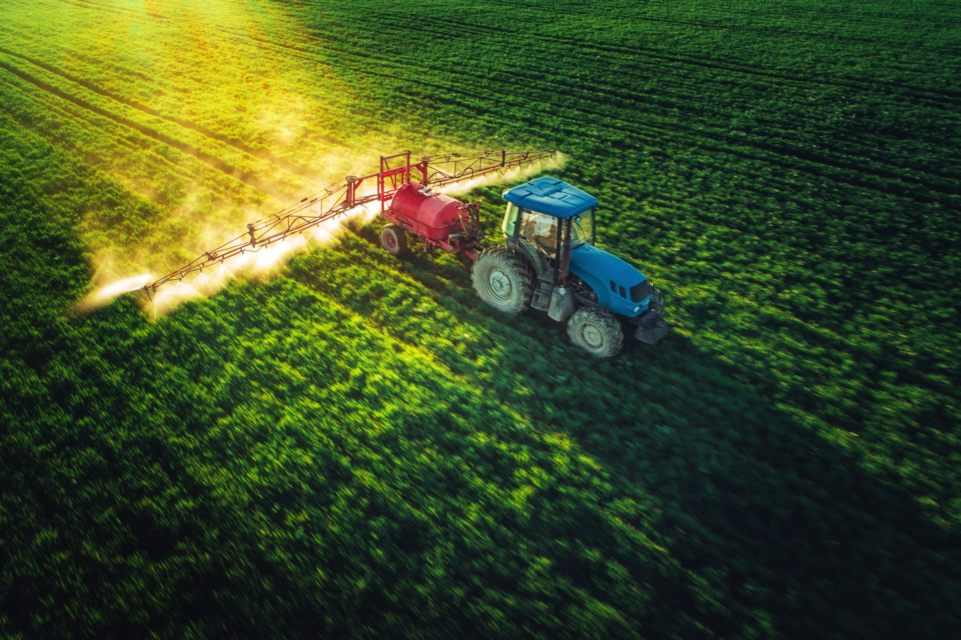

The agriculture industry is a vital sector that encompasses the cultivation of plants, the breeding of animals, and the production of food, fiber, and other essential products. It integrates advanced technologies and scientific research to optimize crop yield, enhance soil health, and improve livestock management. Modern agricultural practices involve the use of precision farming tools, genetically modified organisms, and sustainable techniques to meet the growing global demand for food while minimizing environmental impact. The industry is pivotal in supporting economies, providing employment, and ensuring food security worldwide.

Depending on specific features and functions, GAO Tek’s [Other Material Analyzer](https://gaotek.com/applications-of-ph-meter-in-agricultural-and-soil-analysis/) insert the URL of are sometimes referred to as Multi-Material Analyzer, Composite Material Analyzer, Versatile Material Analyzer, Universal Material Analyzer, Material Composition Analyzer, Comprehensive Material Analyzer, Integrated Material Analyzer, Cross-Material Analyzer, Hybrid Material Analyzer, Advanced Material Analyzer.

Furthermore, GAO Tek’s Other Material Analyzerare further grouped into:

[Moisture Analyzer](https://www.gtek.com/product/moisture-analyzers), [Ash Content Analyzer](https://www.gtek.com/product/ash-content-analyzer), [Protein Analyzer](https://www.gtek.com/product/protein-analyzers)[, Fat Content Analyzer](https://www.gtek.com/product/fat-content-analyzers) and [Density Meter](https://www.gtek.com/product/density-meters)

GAO Tek’ [Other Material Analyzer](https://gaotek.com/applications-of-ph-meter-in-agricultural-and-soil-analysis/) have the following applications inAgriculture Industry:

* GAO Tek's Other Material Analyzer has several applications in the agriculture industry. Our advanced technology enables precise soil analysis, ensuring optimal nutrient management for enhanced crop yields. GAO Tek's analyzers help farmers monitor soil composition, pH levels, and organic matter content, allowing for data-driven decisions to improve soil health.
* We utilize GAO's analyzers to evaluate crop health by detecting nutrient deficiencies, disease presence, and contamination levels. This information allows farmers to apply targeted treatments, reducing waste and improving overall crop quality.
* GAO’s versatile analyzers also play a crucial role in livestock management. By analyzing feed quality and composition, we ensure that livestock receive balanced nutrition, leading to healthier animals and higher productivity.
* Furthermore, GAO Tek's analyzers are used for water quality assessment in irrigation systems. Monitoring water for contaminants and nutrient levels helps us maintain sustainable water usage, crucial for efficient agricultural operations.
* In the realm of precision farming, GAO's advanced analyzers provide critical data that support the implementation of automated systems and smart farming practices, driving innovation and efficiency in the agriculture industry.

More information on Other Material Analyzerand their applications in other industries can be found on this page  [Other Material Analyzer](https://gaotek.com/applications-of-ph-meter-in-agricultural-and-soil-analysis/) This category page lists related products [electrical tester](https://gaotek.com/category/electrical-testers/page/2/).

**Systems in the Agriculture Industry Utilizing Other Material Analyzer**

Here are some popular systems in the Agriculture industry using Other Material Analyzer:

Soil Nutrient Analysis System

* Application: Utilized for assessing soil nutrient levels to optimize fertilizer use.
* Importance of GAO Tek's Analyzers: Provide accurate nutrient composition data.
* Outcome: Enhances crop yields through efficient nutrient management.

Crop Health Monitoring System

* Application: Detects nutrient deficiencies, diseases, and pest infestations in crops.
* Importance of GAO Tek's Analyzers: Use spectral imaging and data analytics for real-time monitoring.
* Outcome: Improves crop health and productivity through timely interventions.

Feed Quality Assessment System

* Application: Analyzes the composition and quality of livestock feed.
* Importance of GAO Tek's Analyzers: Ensure balanced nutrition for livestock.
* Outcome: Promotes healthier animals and enhances productivity in animal husbandry.
* Irrigation Water Quality Monitoring System
* Application: Evaluates water quality for contaminants and nutrient content.
* Importance of GAO Tek's Analyzers: Maintain sustainable irrigation practices.
* Outcome: Optimizes water usage and minimizes environmental impact.

Precision Farming Data Integration System

* Application: Consolidates data from various sensors used in farming.
* Importance of GAO Tek's Analyzers: Provide comprehensive insights into soil and crop conditions.
* Outcome: Facilitates informed decision-making and automation in farming practices.

Post-Harvest Quality Control System

* Application: Analyzes the quality of harvested crops for contaminants and spoilage.
* Importance of GAO Tek's Analyzers: Ensure high-quality produce reaches the market.
* Outcome:

Post-Harvest Quality Control System

* Application: Analyzes the quality of harvested crops for contaminants and spoilage.
* Importance of GAO Tek's Analyzers: Ensure high-quality produce reaches the market.
* Outcome: Enhances food safety and consumer satisfaction.

Greenhouse Environmental Monitoring System

* Application: Tracks and controls parameters like temperature, humidity, and CO2 levels.
* Importance of GAO Tek's Analyzers: Optimize growing conditions in greenhouses.
* Outcome: Promotes healthier plant growth and higher yields in controlled environments.

Soil Moisture and Salinity Monitoring System

* Application: Measures soil moisture levels and salinity for irrigation management.
* Importance of GAO Tek's Analyzers: Prevent over-irrigation and salinity buildup.
* Outcome: Ensures optimal soil conditions for crop growth.

Livestock Health Monitoring System

* Application: Monitors the health and well-being of livestock using biometric sensors.
* Importance of GAO Tek's Analyzers: Track vital signs and activity levels.
* Outcome: Improves animal welfare and farm efficiency through early health issue detection.

Climate Data Collection and Analysis System

* Application: Gathers and analyzes climate data relevant to agricultural activities.
* Importance of GAO Tek's Analyzers: Aid in anticipating weather changes and planning.
* Outcome: Supports climate-resilient farming practices and optimized planting schedules.

GAO Tek’s targeted markets are North America, particularly the U.S., Canada.

**Complying with Government Regulations**

GAO Tek’s spectrum analyzers comply or help our customers comply with the U.S. government regulations such as:

* Federal Insecticide, Fungicide, and Rodenticide Act (FIFRA): This regulation governs the use of pesticides to protect human health and the environment. GAO Tek's analyzers monitor pesticide levels in soil and crops, ensuring compliance with safety standards.
* Food Safety Modernization Act (FSMA): Focused on preventing food contamination during production and processing, this regulation requires monitoring and detection of contaminants. GAO Tek's analyzers help ensure the quality of agricultural products, aligning with FSMA requirements.
* Clean Water Act (CWA): This regulation controls discharges of pollutants into U.S. waters and sets quality standards for surface waters. GAO Tek’s water quality monitoring systems help farmers comply with regulations on water pollution control.
* Resource Conservation and Recovery Act (RCRA): Governing the disposal of solid and hazardous waste, this regulation ensures proper waste management. GAO Tek's analyzers assist in managing and reducing agricultural waste, ensuring adherence to RCRA guidelines.
* National Organic Program (NOP): Establishing standards for organically produced agricultural products, this regulation ensures organic integrity. GAO Tek's systems help monitor and verify organic farming practices, ensuring compliance with NOP standards.
* Safe Drinking Water Act (SDWA): Protecting the quality of drinking water in the U.S., this regulation sets standards for safe drinking water. GAO Tek's analyzers assess the quality of water used in irrigation and livestock, helping to meet SDWA requirements.
* Occupational Safety and Health Administration (OSHA) Standards: Ensuring safe and healthy working conditions, these standards apply to agricultural settings. GAO Tek's analyzers monitor environmental conditions to enhance workplace safety and comply with OSHA regulations.
* Toxic Substances Control Act (TSCA): Regulating the introduction of new or existing chemicals, this act ensures chemical safety. GAO Tek's analyzers help detect and manage toxic substances in the agricultural environment, supporting TSCA compliance.

GAO Tek’s Other Material Analyzercomply or help our clients comply with the Canadian regulations such as:

* Innovation, Science and Economic Development Canada (ISED) RSS-Gen
* ISED RSS-210
* ISED RSS-247
* Canadian Environmental Protection Act (CEPA)
* National Building Code of Canada (NBC)
* Canadian Standards Association (CSA) C22.1
* Canadian Electrical Code (CEC)
* Occupational Health and Safety (OHS) Regulations
* Radiocommunication Act

**Case Studies of Other Material Analyzer in Agriculture Industry**

Agricultural Sensor Technologies Inc., based in Iowa, implemented Other Material Analyzers to enhance soil fertility management in large-scale farming operations. By utilizing these analyzers to assess soil nutrient levels, pH, and moisture content, farmers could precisely tailor their fertilization and irrigation strategies, resulting in improved crop yields and reduced environmental impact.

In Ontario, a vineyard and winery adopted Other Material Analyzers to monitor grape ripeness and sugar content during the harvest season. By employing near-infrared spectroscopy, winemakers could non-destructively analyze grape samples in real-time, enabling more accurate harvesting decisions and optimizing the quality of the final wine product.

A livestock farm in Alberta integrated Other Material Analyzers into their feed analysis process to ensure the nutritional balance of animal feed formulations. By analyzing the composition of feed ingredients for protein, fiber, and moisture content, farmers could formulate diets that met the specific dietary requirements of their livestock, leading to healthier animals and improved production efficiency.

In Saskatchewan, a grain elevator company utilized Other Material Analyzers to assess the quality of incoming grain shipments. By analyzing samples for moisture content, protein levels, and foreign material, the company could accurately grade and segregate grain batches, ensuring compliance with industry standards and meeting the needs of various end-users, such as food processors and livestock feed manufacturers.

A research institution in British Columbia employed Other Material Analyzers to study the effects of environmental factors on crop nutrient uptake and plant health. By conducting spectral analysis of plant tissues, researchers could identify nutrient deficiencies and optimize fertilization strategies to maximize crop productivity while minimizing nutrient loss and environmental pollution.

These case studies demonstrate the diverse applications of Other Material Analyzers in the agriculture industry, from soil and feed analysis to crop monitoring and quality control, highlighting their importance in supporting sustainable and efficient agricultural practices.

GAO RFID Inc. <https://gaorfid.com>, a sister company of GAO Tek Inc., is ranked as a top 10 RFID supplier in the world. Its RFID, BLE, and IoT products have also been widely used in construction industry.

* [Agricultural Industries](https://gaorfid.com/agricultural-industries-market-report/)
* [Applications of Other Material Analyzers in the Information](https://gaotek.com/applications-of-other-material-analyzers-in-the-information-industry/)

**Use of Other Material Analyzers with Leading Software and Cloud Services in construction industry**

GAO Tek has used or has facilitated its customers to use GAO’s “products” with some of the leading software and cloud services in their applications. Examples of such leading software and cloud services include:

* FarmLogs
* Granular
* Trimble Ag Software
* Climate FieldView
* AgStudio
* Agrian
* FieldNET by Lindsay
* Iteris ClearAg

GAO Tek’s Other Material Analyzersand their applications in other industries are listed on this page[Other Material Analyzer](https://gaotek.com/applications-of-ph-meter-in-agricultural-and-soil-analysis/). Other related products can be found at this category page [electrical tester](https://gaotek.com/category/electrical-testers/page/2/).

**Meeting Customers’ Demands**

**Large Choice of Products**

In order to satisfy the diversified needs of their corporate customers, GAO Tek Inc. and its sister company GAO RFID Inc. together offer a wide choice of testing and measurement devices, network products, RFID, BLE, IoT, and drones.

**Fast Delivery**

To shorten the delivery to our customers, GAO has maintained a large stock of its products and is able to ship overnight within the continental U.S. and Canada from the nearest warehouse.

**Local to Our Customers**

We are located in both the U.S. and Canada. We travel to customers’ premises if necessary. Hence, we provide a very strong local support to our customers in North America, particularly the U.S., Canada. Furthermore, we have built partnerships with some integrators, consulting firms and other service providers in different cities to further strengthen our services. Here are some of the service providers in agriculture industry we have worked with to serve our joint customers:

* Accenture
* Deloitte
* IBM
* Cognizant
* Infosys
* TATA Consultancy Services (TCS)
* CGI
* Capgemini
* Wipro
* Tech Mahindra
* Atos
* DXC Technology
* HCL Technologies
* NTT DATA
* Accenture (Canada)
* Deloitte (Canada)
* IBM (Canada)
* Cognizant (Canada)
* Infosys (Canada)
* TATA Consultancy Services (TCS) (Canada)
* CGI (Canada)
* Capgemini (Canada)
* Wipro (Canada)
* Tech Mahindra (Canada)
* Atos (Canada)
* DXC Technology (Canada)
* HCL Technologies (Canada)

**GAO Has Many Customers in the Agriculture industry**

The products from both GAO Tek Inc. and GAO RFID Inc. have been widely used in Agriculture industry by many customers, including some leading companies. Here is more information on applications of GAO RFID Inc.’s products in Robotic industry.

* [Agricultural Industries](https://gaorfid.com/agricultural-industries-market-report/)
* [Applications of Other Material Analyzers in the Information](https://gaotek.com/applications-of-other-material-analyzers-in-the-information-industry/)

Here are some of GAO’s customers in Robotic industry:

* Monsanto
* John Deere
* Archer Daniels Midland (ADM)
* DuPont
* Bayer CropScience
* Syngenta
* Cargill
* BASF
* Tyson Foods
* Deere & Company
* Dow AgroSciences
* AGCO Corporation
* Wilbur-Ellis Company
* Zoetis
* Smithfield Foods
* CHS Inc.
* Land O'Lakes
* Valmont Industries
* ADM Milling Company
* Nutrien
* Agrium
* Richardson International
* Viterra
* Maple Leaf Foods
* Bunge Canada

|  |  |  |  |  |  |
| --- | --- | --- | --- | --- | --- |
| Monsanto — BUSINESS FOR 2030  Monsanto | John Deere  John Deere | Archer Daniels Midland: Selection and ...  (ADM) | DuPont's deadly deceit: The decades ...  DuPont | Bayer CropScience Will Expand Presence ...  Bayer CropScience | Syngenta led initiative to help farmers ...Syngenta |
| Media Assets Library | Cargill IndiaCargill | Here is why chemical company BASF will ...  BASF | Tyson BrandTyson Foods | John Deere partners with outdoor power ...  Deere & Company | Dow AgroSciences – Ohio Ag Net | Ohio's ...Dow AgroSciences | AGCO Corporation - YouTubeAGCO Corporation |
| Wilbur Ellis | LinkedInWilbur-Ellis Company | Home | Zoetis  Zoetis | Smithfield Foods | LinkedInSmithfield Foods | CHS Reports First Quarter Fiscal Year ...  CHS Inc. | Land O'Lakes reports continued share ...  Land O'Lakes | Valmont Industries, Inc.Valmont Industries |
| Nutrien Ag Solutions - YouTubeNutrien | Agrium | LinkedInAgrium | Richardson International | LinkedInRichardson International | Viterra Brand Value & Company Profile ...  Viterra | Maple Leaf Foods Reduces Plant-Based ...  Maple Leaf Foods | Canada concerned over Bunge, Viterra mergerBunge Canada |

This resource page is for [spectrum analyzers](https://gaotek.com/product/gaotek-high-performance-spectrum-analyzer-for-wide-frequency-range/) .

To facilitate our customers to select our products, we have further classified function generators by their features [Moisture Analyzer](https://www.gtek.com/product/moisture-analyzers), [Ash Content Analyzer](https://www.gtek.com/product/ash-content-analyzer), [Protein Analyzer](https://www.gtek.com/product/protein-analyzers)[, Fat Content Analyzer](https://www.gtek.com/product/fat-content-analyzers) and [Density Meter](https://www.gtek.com/product/density-meters)

Below are other resource containing useful information on Spectrum Analyzer:

[FAQs on on Spectrum Analyzer GAOTek.com](https://gaotek.com/category/electrical-testers/rf-spectrum-analyzers/)

[How to Choose Spectrum Analyzer](https://www.lisungroup.com/news/technology-news/choosing-the-right-spectrum-analyzer-for-your-needs-a-buying-guide.html)

[Components of Spectrum Analyzer](http://www.ee.nmt.edu/~rison/ee435_spr10/SpectrumAnalysisBasics.pdf)

[Operation, Maintenance & Calibration of a Spectrum Analyzer](https://gaotek.com/operation-maintenance-and-calibration-of-a-spectrum-analyzer/)

[Customers in the U.S. and Canada of Spectrum Analyzer](https://www.persistencemarketresearch.com/market-research/spectrum-analyzer-market.asp)

[Applications of spectrum analyzers in construction industry](https://www.lisungroup.com/news/technology-news/what-is-a-spectrum-analyzer-and-explain-its-applications.html)

**Contact Us**

Here are GAO Tek’s [Other Material Analyzer](https://gaotek.com/applications-of-ph-meter-in-agricultural-and-soil-analysis/) and they are further organized by feature: [Moisture Analyzer](https://www.gtek.com/product/moisture-analyzers), [Ash Content Analyzer](https://www.gtek.com/product/ash-content-analyzer), [Protein Analyzer](https://www.gtek.com/product/protein-analyzers)[, Fat Content Analyzer](https://www.gtek.com/product/fat-content-analyzers) and [Density Meter](https://www.gtek.com/product/density-meters)

We ship overnight to anywhere on continental U.S. and Canada from one of our local warehouses.

If you have any questions about our products or want to place an order, our technical experts can help you. Please [fill out this form](https://gaotek.com/ask-an-expert/)  or [email us](mailto:sales@gaotek.com).